**Department of Veterans Affairs**

**Org Chart**

**My HealtheVet**



**July 2021**

**Version 2.4**

**Revision History**

| **Date** | **Version** | **Description** | **Author** |
| --- | --- | --- | --- |
| 12 July 2021 | 2.4 | Updated Org Chart for onboarding and offboarding personnel and changing Delivery Managers around NOTE: New UX resources still need to be added to correct team, once assigned – they are not listed on Org Chart at this time | Melinda LaTona |
| 12 May 2021 | 2.3 | Added Laura Meier/Business Analyst under Platform Support | Melinda LaTona |
| 28 April 2021 | 2.2 | Removed Lathan Swepson from UX across the teams | Melinda LaTona |
| 28 April 2021 | 2.1 | Removed Elizabeth Holmes from Communications, moved Steve Clements from PHR to National Portal, and Merged Appointments, Batch and PHR into one team | Melinda LaTona |
| 21 April 2021 | 2.0 | Removed Praneeth Gaganapally and replaced with Sanjay Gupta on Patient Data - PGHD and Pharmacy Team. | Melinda LaTona |
| 21 April 2021 | 1.9 | Removed Sarah Makai from Portals and Access | Melinda LaTona |
| 15 April 2021 | 1.8 | Removed Chloe McMasters (Analyst) / Gov and Elizabeth Holm (UX)/Patient Data | Melinda LaTona |
| 09 April 2021 | 1.7 | Renamed “Access and HLA” to just “Access”, Removed Swathi from “Appointments and Batch” and added Swathi to “Access” only. | Melinda LaTona |
| 09 April 2021 | 1.6 | Updated Patient Data, Communications, and Portals and Access teams with UX member changes | Melinda LaTona |
| 01 April 2021 | 1.5 | Added Elizabeth Holmes to Patient Data (UX) | Melinda LaTona |
| 24 Mar 2021 | 1.4 | Removed Functional Analyst from Patient Data and Communications and removed Mark Babcock from Security | Melinda LaTona |
| 24 Mar 2021 | 1.3 | Added / Removed latest personnel (Added: Jeremy Farmer – Platform Operations, Robert Bailey - UX, Jie Zhao - Security, Justin Todd – Security; Removed Robert Wojtow) | Melinda LaTona |
| 22 Jan 2021 | 1.2 | Remove Mark Babcock from CM/RM and add in Janiece Wade and added Table of Figures | Melinda LaTona |
| 18 Jan 2021 | 1.1 | Minor Updates | Melinda LaTona |
| 14 Jan 2021 | 1.0 | Updated Org chart to remove Tom Hormby and Rich Copeman and updated Tier 3, Platform Support, Platform Working Group and Portals/Access. Updated Manpower Report for latest as of Jan 14, 2021. | Melinda LaTona |

Contents

Figure 1 - Patient Data 5

Figure 2 - Communications 6

Figure 3 - Portals 7

Figure 4 - Platform Support 8

Figure 5 - Platform Support Working Groups 8

Figure 6 - Governance & Program Support 9

Figure 7 - PMO 10

**Patient Data – Group Appointments, Personal Health Record (PHR), Pharmacy & Patient Generated Health Data (PGHD)**

Figure 1 - Patient Data

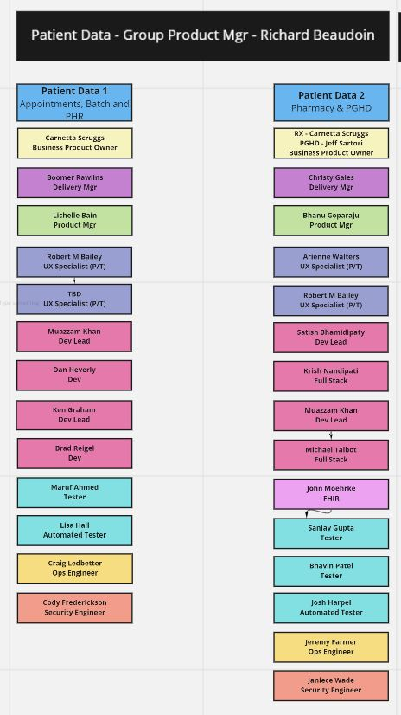

Figure 2 - Communications

**Communications: Secure Messaging**

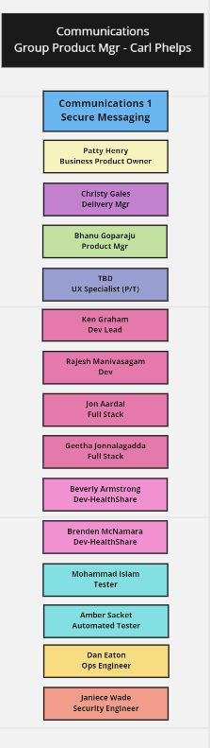

Figure 3 - Portals

**Portals: National Portal, Access, HealtheLiving Assessment (HLA), SM Admin, and Admin**

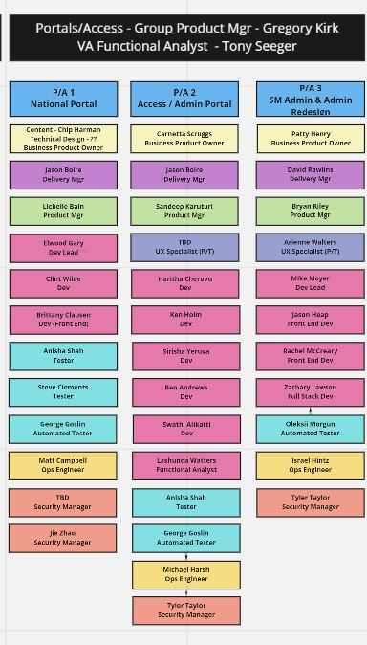

Figure 4 - Platform Support

**Platform Group: Automated Test, Tier 3, CM/RM/CI/CD, Dev and Ops Support**

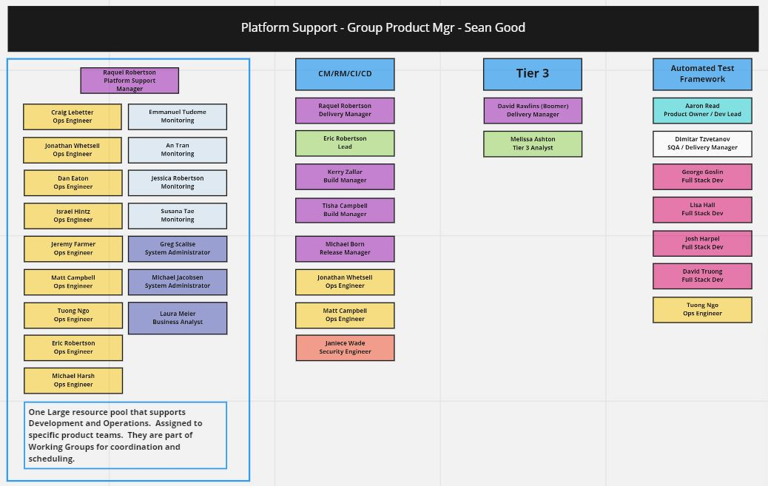

Figure 5 - Platform Support Working Groups

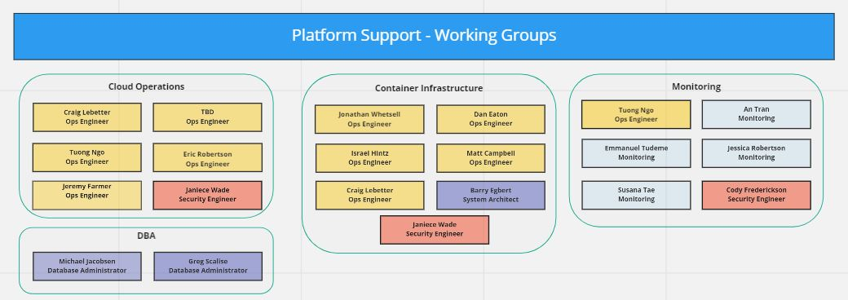

Figure 6 - Governance & Program Support

**Governance & Program Support: Compliance & Documentation, Security and API Oversight**

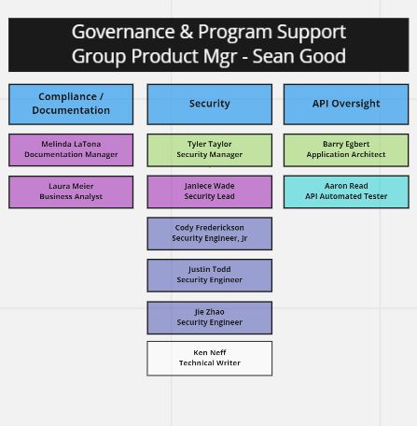

Figure 7 - PMO

**PMO**

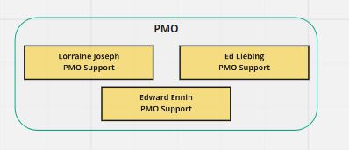

**NOTE: Additional folks to be added once assigned to a team as of 07122021:**

* **Gavin Quinn - UX**
* **Yessica Perez Losada (Andrea) – UX**
* **Alexia Wunder – UX**